**Third Progress Report**

**Design Approach :**

**ER diagram**

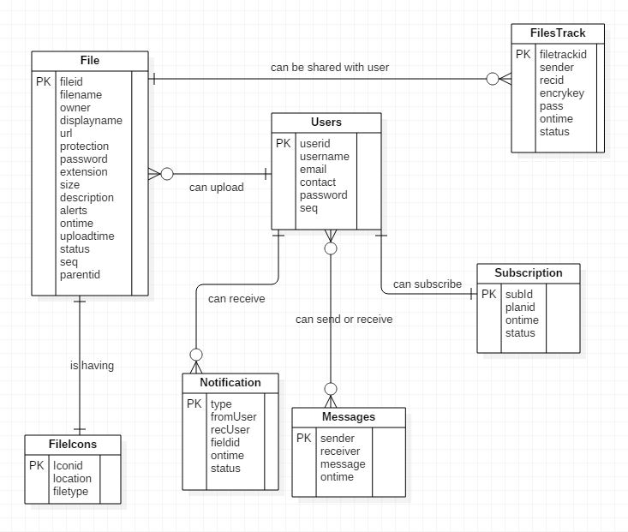

**Fig : ER Diagram**

**Class diagram :**

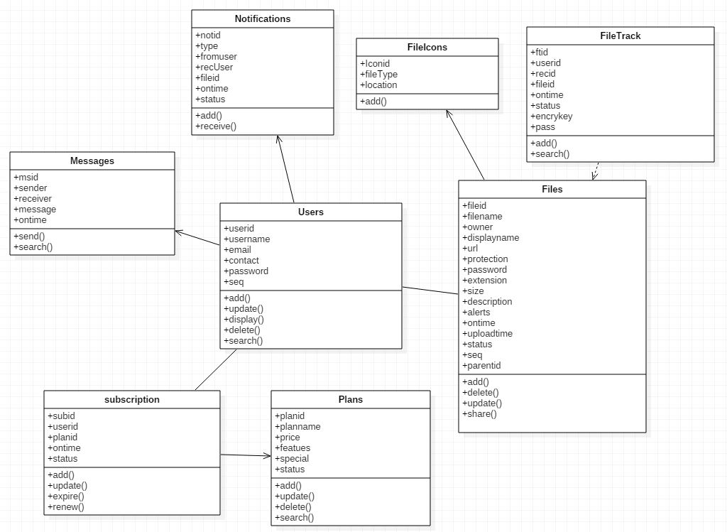

**Fig : Class diagram**

**Implementation :**

**User Manual :**

The purpose of this manual is to provide a set of flexible, adaptable tools, and guidelines to support users in their role.

**User :**

* Enter the “USERNAME” and “PASSWORD” and click on SUBMIT button.
* If the combination of username and password is correct the system displays the dashboard page and it includes

1. ADD FILE– Herethe User can select and upload the files to the drive.
2. VIEW FILE DETAILS – The user can view the complete details of the uploaded files.
3. ACCOUNT SETTINGS – User can change the password for security reasons.

**Output Screens :**

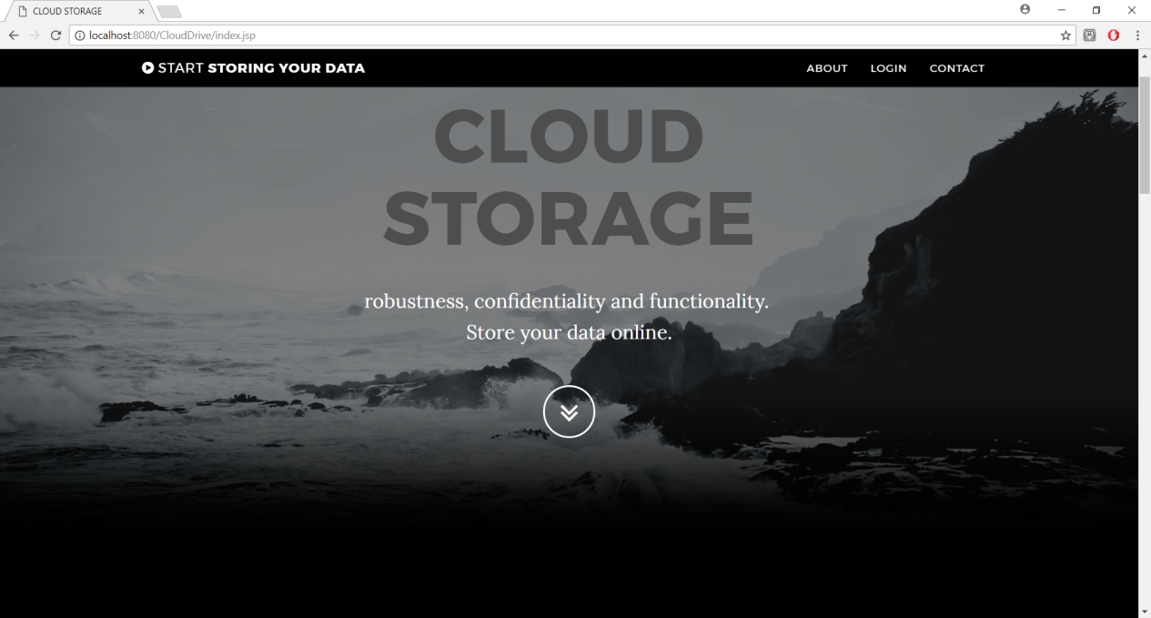

**Fig 1 – Home Page**

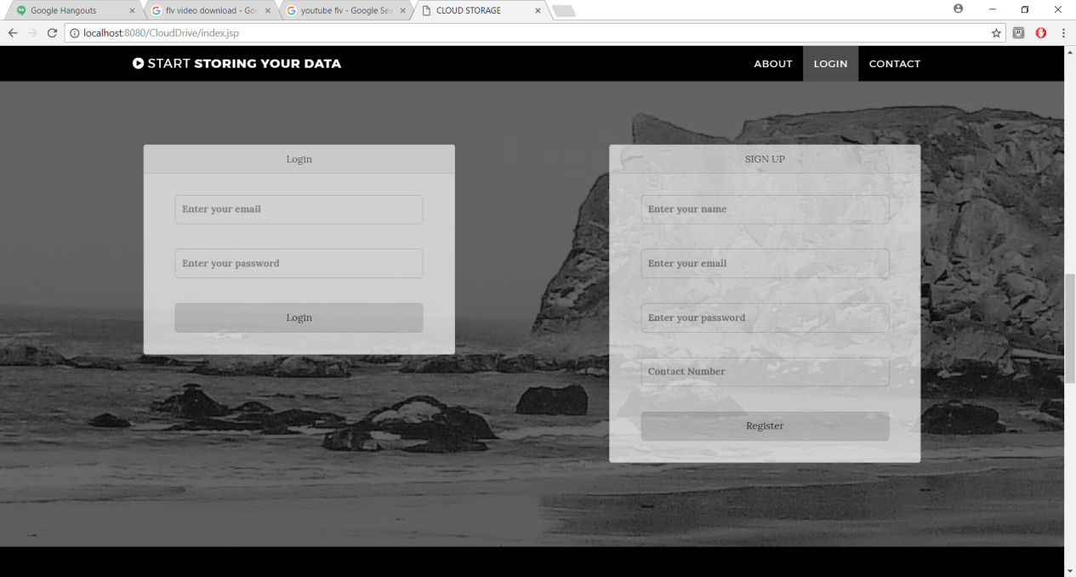

**Fig 2 – Login Page**

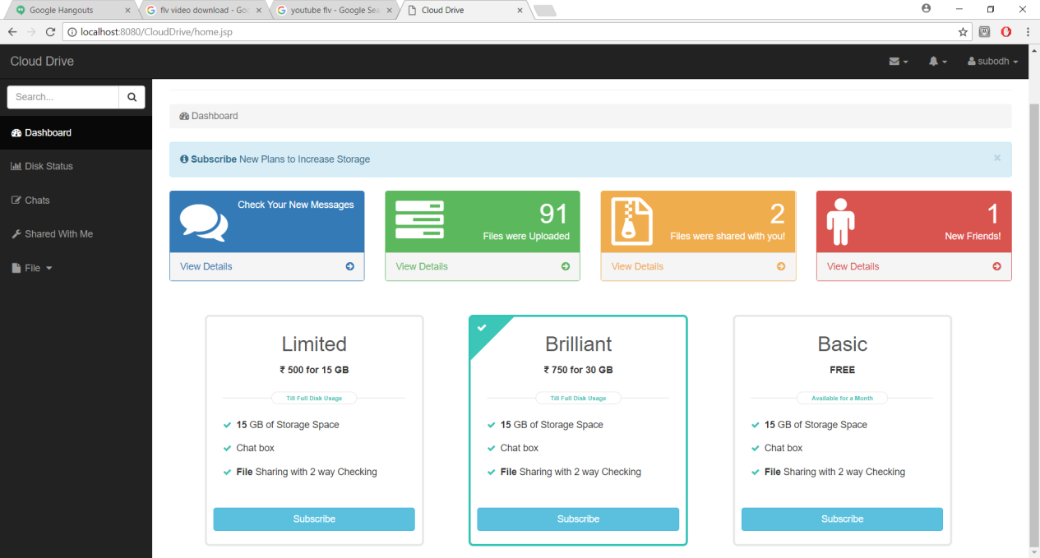

**Fig 3 – Dashboard**

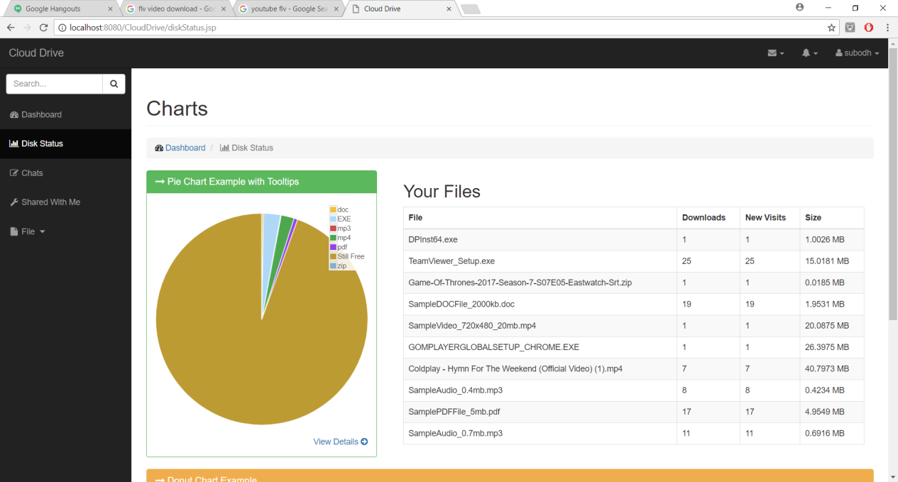

**Fig 4 – Disk Status**

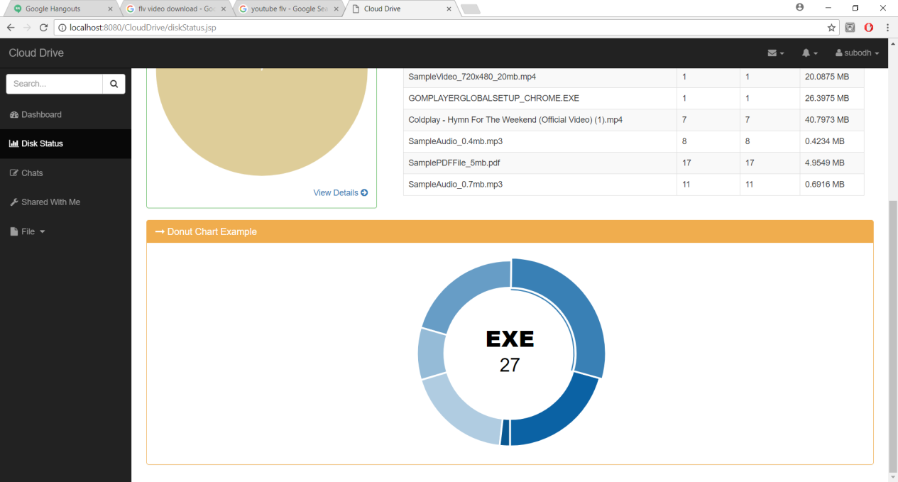

**Fig 5 – Disk Status**

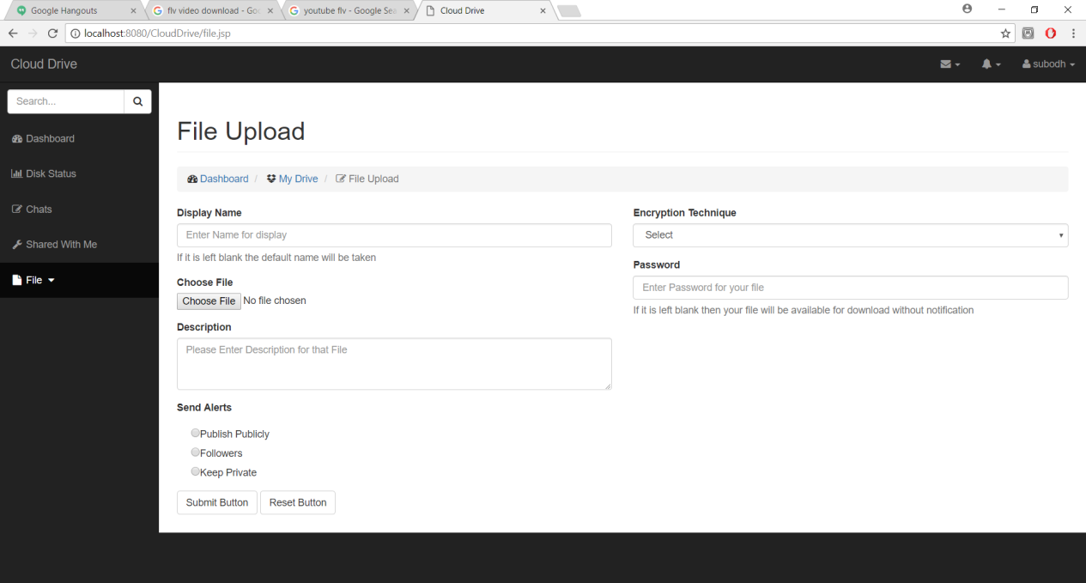

**Fig 6 – File Upload**

**Source Code:**

Source Code

**Limitation & Enhancement :**

* **Limitations :**
* The user can perform more computation and communication traffic between the user and storage servers is high.
* The user has to manage his cryptographic keys otherwise the security has to be broken.
* The data storing and retrieving, it is hard for storage servers to directly support other functions.
* **Enhancement :**
* We think that not a single project is ever considered as complete forever because our mind is always thinking new and our necessities also are growing.
* Our application Also, if you see at the first glance that you find it to be complete but I want to make it still mature and fully automatic.
* The system is modified in future as per the User’s requirement.
* The subscription plan can be renewed by the user.
* More encryption techniques could be provided.

**Conclusion:**

* Finally we would like to conclude that while working on this project I have learned many new technologies, concepts.
* The project Cloud Storage system is based and is under the java technology.
* This insulates the application from technical implementation and enhancement to support future technologies in a transparent manner without having the major impact on the application.
* This also enables the easy portability of application to other operating system and databases.
* Thus, I was able to understand in greater details the various software engineering processes, and were able to apply them to our live project.
* With this enduring and simulating experience we admit that the people of this website have really enlightened us. With due regards, we would express our heart-felt thanks to all for their support and cooperation towards the completion of our project.